**ARTIFICIAL INTELLIGENCE & MACHINE LEARNING**

**MR23-1CS0223 - Design and Analysis of Algorithms**

**Holiday Assignment**

**by 2311cs020200**

**Golla Prashanth**

**Aiml -Omega**

1. Check whether given number is Palindrome or not.

Ans. #include <stdio.h>

int main() {

int num, reversedNum = 0, remainder, originalNum;

// Input from the user

printf("Enter an integer: ");

scanf("%d", &num);

originalNum = num; // Store the original number

// Reverse the number

while (num != 0) {

remainder = num % 10;

reversedNum = reversedNum * 10 + remainder;

num /= 10;

}

// Check if the original number and reversed number are the same

if (originalNum == reversedNum) {

printf("%d is a palindrome number.\n", originalNum);

} else {

printf("%d is not a palindrome number.\n", originalNum);

}

return 0;

}

Output:

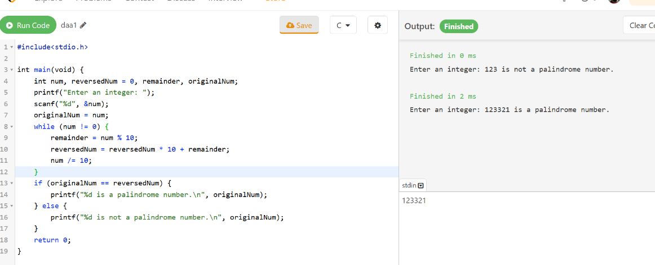

1. Convert the Roman to integer.

Ans. #include <stdio.h>

#include <string.h>

// Function to return the integer value of a Roman numeral character

int romanToInt(char c) {

switch (c) {

case 'I': return 1;

case 'V': return 5;

case 'X': return 10;

case 'L': return 50;

case 'C': return 100;

case 'D': return 500;

case 'M': return 1000;

default: return 0; // Invalid character

}

}

// Function to convert a Roman numeral string to an integer

int convertRomanToInt(char *roman) {

int i, total = 0, current, next;

int length = strlen(roman);

for (i = 0; i < length; i++) {

current = romanToInt(roman[i]);

if (i + 1 < length) {

next = romanToInt(roman[i + 1]);

// If the current value is less than the next value, subtract it

if (current < next) {

total -= current;

} else {

total += current;

}

} else {

total += current; // Add the last value

}

}

return total;

}

int main() {

char roman[20];

// Input Roman numeral from the user

printf("Enter a Roman numeral: ");

scanf("%s", roman);

// Convert Roman numeral to integer and print the result

int result = convertRomanToInt(roman);

printf("The integer value of %s is %d.\n", roman, result);

return 0;

}

Output:

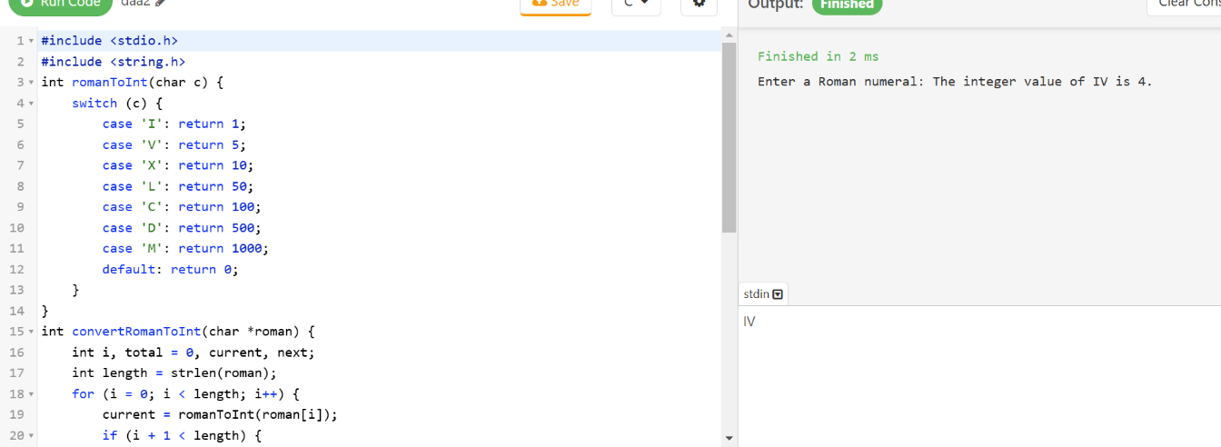

1. Validating opening and closing parenthesis in a String

Ans. #include <stdio.h>

#include <stdbool.h>

#include <string.h>

// Function to validate if the parentheses are balanced

bool isValidParentheses(char *str) {

int stack[100]; // Stack to keep track of open parentheses

int top = -1; // Top of the stack

for (int i = 0; str[i] != '\0'; i++) {

char ch = str[i];

// Push opening parentheses onto the stack

if (ch == '(' || ch == '{' || ch == '[') {

stack[++top] = ch;

}

// Check closing parentheses

else if (ch == ')' || ch == '}' || ch == ']') {

if (top == -1) {

// Stack is empty, so no matching opening parenthesis

return false;

}

// Check if the current closing parenthesis matches the top of the stack

char topChar = stack[top--];

if ((ch == ')' && topChar != '(') ||

(ch == '}' && topChar != '{') ||

(ch == ']' && topChar != '[')) {

return false;

}

}

}

// If stack is empty, all parentheses are matched

return top == -1;

}

int main() {

char str[100];

// Input string from the user

printf("Enter a string with parentheses: ");

scanf("%s", str);

// Validate the parentheses

if (isValidParentheses(str)) {

printf("The parentheses in the string are balanced.\n");

} else {

printf("The parentheses in the string are not balanced.\n");

}

return 0;

}

Output:

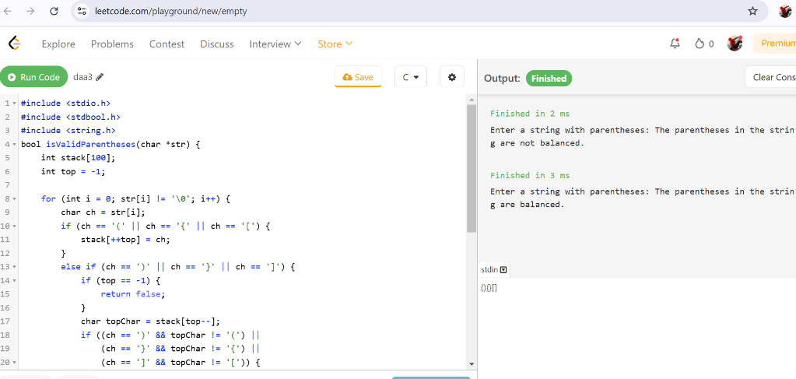

1. Finding Odd and even numbers in an Array

Ans. #include <stdio.h>

int main() {

int n, i;

// Input size of the array

printf("Enter the size of the array: ");

scanf("%d", &n);

int arr[n], odd[n], even[n];

int oddCount = 0, evenCount = 0;

// Input array elements

printf("Enter %d elements of the array:\n", n);

for (i = 0; i < n; i++) {

scanf("%d", &arr[i]);

}

// Separate odd and even numbers

for (i = 0; i < n; i++) {

if (arr[i] % 2 == 0) {

even[evenCount++] = arr[i]; // Add to even array

} else {

odd[oddCount++] = arr[i]; // Add to odd array

}

}

// Print even numbers

printf("Even numbers in the array: ");

for (i = 0; i < evenCount; i++) {

printf("%d ", even[i]);

}

printf("\n");

// Print odd numbers

printf("Odd numbers in the array: ");

for (i = 0; i < oddCount; i++) {

printf("%d ", odd[i]);

}

printf("\n");

return 0;

}

Output:

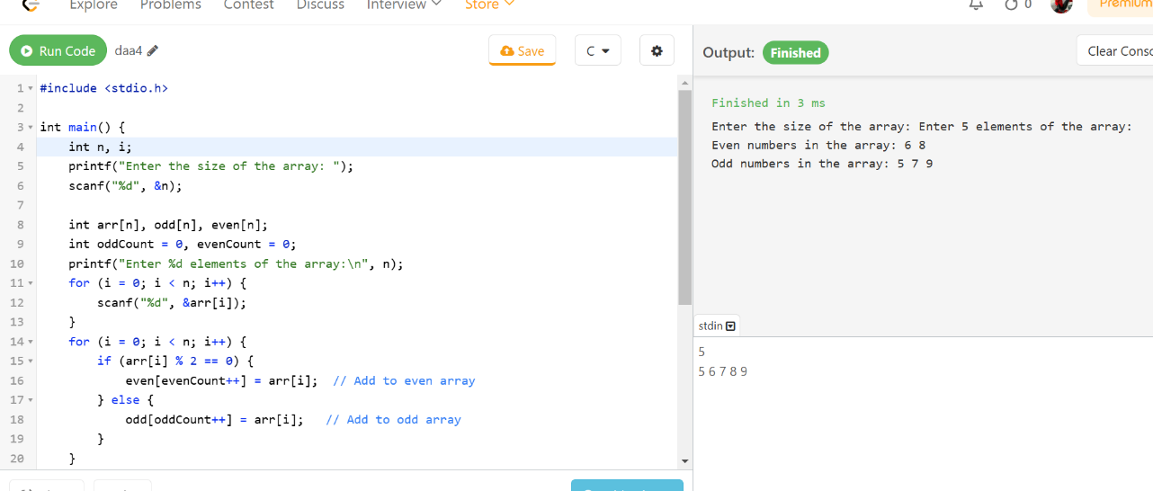

1. Find all symmetric pairs in array of pairs. Given an array of pairs of integers, find all symmetric pairs, i.e., pairs that mirror each other. For instance, pairs (x, y) and (y, x) are mirrors of each other.

Ans. #include <stdio.h>

void findSymmetricPairs(int pairs[][2], int n) {

printf("Symmetric pairs are:\n");

for (int i = 0; i < n; i++) {

for (int j = i + 1; j < n; j++) {

if (pairs[i][0] == pairs[j][1] && pairs[i][1] == pairs[j][0]) {

printf("(%d, %d) and (%d, %d)\n", pairs[i][0], pairs[i][1], pairs[j][0], pairs[j][1]);

}

}

}

}

int main() {

int n;

printf("Enter the number of pairs: ");

scanf("%d", &n);

int pairs[n][2];

printf("Enter the pairs:\n");

for (int i = 0; i < n; i++) {

scanf("%d %d", &pairs[i][0], &pairs[i][1]);

}

findSymmetricPairs(pairs, n);

return 0;

}

Output:

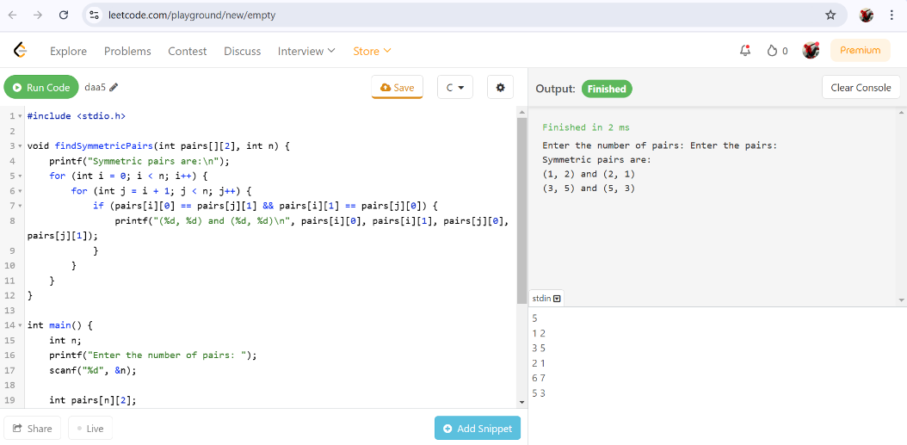

1. Find the Kth smallest element in an Array using function.

Ans. #include <stdio.h>

int partition(int arr[], int low, int high) {

int pivot = arr[high];

int i = low - 1;

for (int j = low; j < high; j++) {

if (arr[j] < pivot) {

i++;

int temp = arr[i];

arr[i] = arr[j];

arr[j] = temp;

}

}

int temp = arr[i + 1];

arr[i + 1] = arr[high];

arr[high] = temp;

return i + 1;

}

int kthSmallest(int arr[], int low, int high, int k) {

if (low <= high) {

int pi = partition(arr, low, high);

if (pi == k - 1) {

return arr[pi];

} else if (pi > k - 1) {

return kthSmallest(arr, low, pi - 1, k);

} else {

return kthSmallest(arr, pi + 1, high, k);

}

}

return -1;

}

int main() {

int n, k;

printf("Enter the size of the array: ");

scanf("%d", &n);

int arr[n];

printf("Enter %d elements of the array:\n", n);

for (int i = 0; i < n; i++) {

scanf("%d", &arr[i]);

}

printf("Enter the value of k: ");

scanf("%d", &k);

int result = kthSmallest(arr, 0, n - 1, k);

if (result != -1) {

printf("The %dth smallest element is %d.\n", k, result);

} else {

printf("Invalid value of k.\n");

}

return 0;

}

Output:

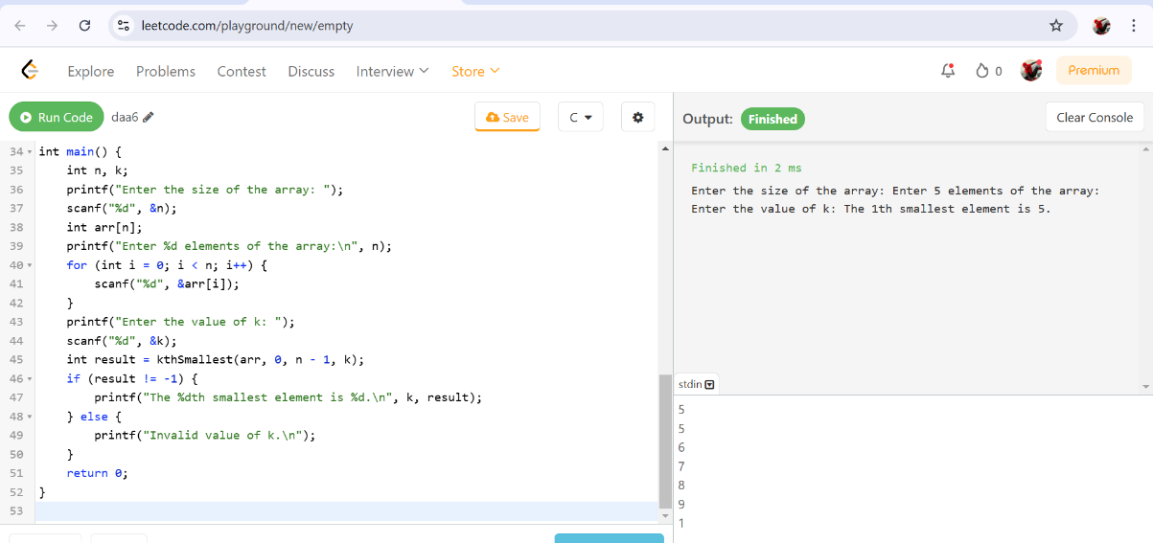

1. Create a structure named Complex to represent a complex number with real and imaginary parts. Write a C program to add and multiply two complex numbers.

Ans. #include <stdio.h>

typedef struct {

float real;

float imag;

} Complex;

Complex addComplex(Complex c1, Complex c2) {

Complex result;

result.real = c1.real + c2.real;

result.imag = c1.imag + c2.imag;

return result;

}

Complex multiplyComplex(Complex c1, Complex c2) {

Complex result;

result.real = c1.real * c2.real - c1.imag * c2.imag;

result.imag = c1.real * c2.imag + c1.imag * c2.real;

return result;

}

int main() {

Complex c1, c2, sum, product;

printf("Enter the real and imaginary parts of the first complex number: ");

scanf("%f %f", &c1.real, &c1.imag);

printf("Enter the real and imaginary parts of the second complex number: ");

scanf("%f %f", &c2.real, &c2.imag);

sum = addComplex(c1, c2);

product = multiplyComplex(c1, c2);

printf("Sum of the complex numbers: %.2f + %.2fi\n", sum.real, sum.imag);

printf("Product of the complex numbers: %.2f + %.2fi\n", product.real, product.imag);

return 0;

}

Output:

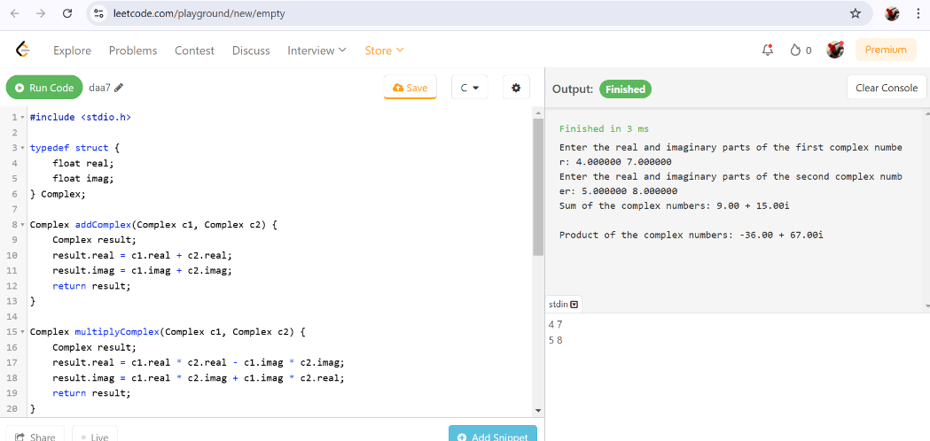

1. Find the missing and duplicate number in an Array

Ans. #include <stdio.h>

void findMissingAndDuplicate(int arr[], int n) {

int i, missing = -1, duplicate = -1;

int count[n + 1];

for (i = 0; i <= n; i++) {

count[i] = 0;

}

for (i = 0; i < n; i++) {

count[arr[i]]++;

}

for (i = 1; i <= n; i++) {

if (count[i] == 0) {

missing = i;

}

if (count[i] > 1) {

duplicate = i;

}

}

printf("Duplicate number: %d\n", duplicate);

printf("Missing number: %d\n", missing);

}

int main() {

int n, i;

printf("Enter the size of the array (n): ");

scanf("%d", &n);

int arr[n];

printf("Enter %d elements (1 to n):\n", n);

for (i = 0; i < n; i++) {

scanf("%d", &arr[i]);

}

findMissingAndDuplicate(arr, n);

return 0;

}

Output:

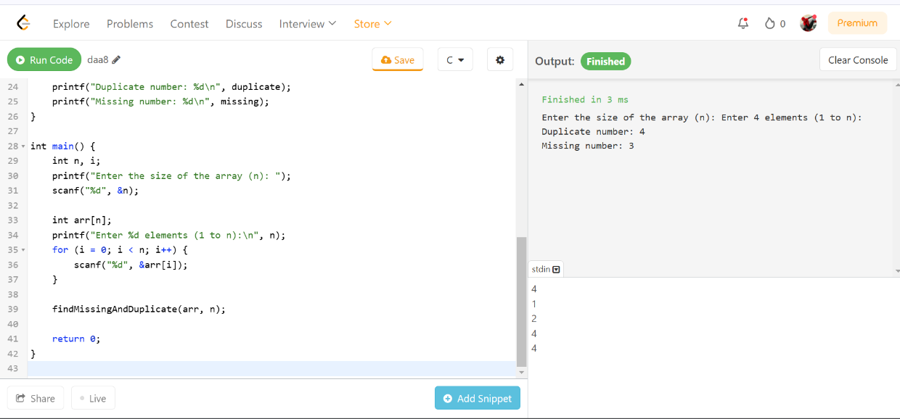

1. Write C program to determine if a number n is happy. A happy number is a number defined by the following process:

* Starting with any positive integer, replace the number by the sum of the squares of its digits.
* Repeat the process until the number equals 1 (where it will stay), or it loops endlessly in a cycle which does not include 1.
* Those numbers for which this process ends in 1 are happy.

Return true if n is a happy number, and false if not.

**Input**: n = 19

**Output**: true

**Explanation:**

12 + 92 = 82

82 + 22 = 68

62 + 82 = 100

12 + 02 + 02 = 1

Ans. #include <stdio.h>

#include <stdbool.h>

int sumOfSquares(int n) {

int sum = 0;

while (n > 0) {

int digit = n % 10;

sum += digit * digit;

n /= 10;

}

return sum;

}

bool isHappy(int n) {

int slow = n, fast = n;

do {

slow = sumOfSquares(slow);

fast = sumOfSquares(sumOfSquares(fast));

} while (slow != fast);

return slow == 1;

}

int main() {

int n;

printf("Enter a number: ");

scanf("%d", &n);

if (isHappy(n)) {

printf("%d is a happy number.\n", n);

} else {

printf("%d is not a happy number.\n", n);

}

return 0;

}

Output:

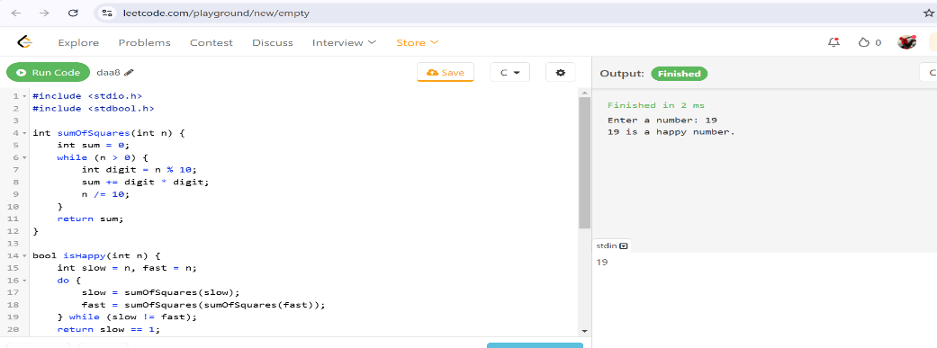

1. Given a binary tree, determine if it is height-balanced:

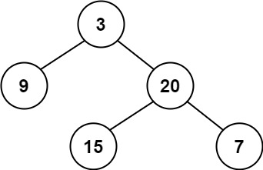

**Input**: root = [3, 9, 20, null, null, 15, 7]

**Output**: true

Ans. #include <stdio.h>

#include <stdlib.h>

#include <stdbool.h>

typedef struct BinaryTreeNode {

int val;

struct BinaryTreeNode* left;

struct BinaryTreeNode* right;

} BinaryTreeNode;

BinaryTreeNode* createNode(int val) {

BinaryTreeNode* node = (BinaryTreeNode*)malloc(sizeof(BinaryTreeNode));

node->val = val;

node->left = NULL;

node->right = NULL;

return node;

}

BinaryTreeNode* insertNode() {

int val;

printf("Enter node value (-1 for NULL): ");

scanf("%d", &val);

if (val == -1) {

return NULL;

}

BinaryTreeNode* node = createNode(val);

printf("Enter left child of %d:\n", val);

node->left = insertNode();

printf("Enter right child of %d:\n", val);

node->right = insertNode();

return node;

}

int height(BinaryTreeNode* root) {

if (root == NULL) {

return 0;

}

int leftHeight = height(root->left);

int rightHeight = height(root->right);

if (leftHeight == -1 || rightHeight == -1 || abs(leftHeight - rightHeight) > 1) {

return -1;

}

return 1 + (leftHeight > rightHeight ? leftHeight : rightHeight);

}

bool isBalanced(BinaryTreeNode* root) {

return height(root) != -1;

}

int main() {

printf("Create the binary tree:\n");

BinaryTreeNode* root = insertNode();

if (isBalanced(root)) {

printf("The tree is height-balanced.\n");

} else {

printf("The tree is not height-balanced.\n");

}

return 0;

}

Output:

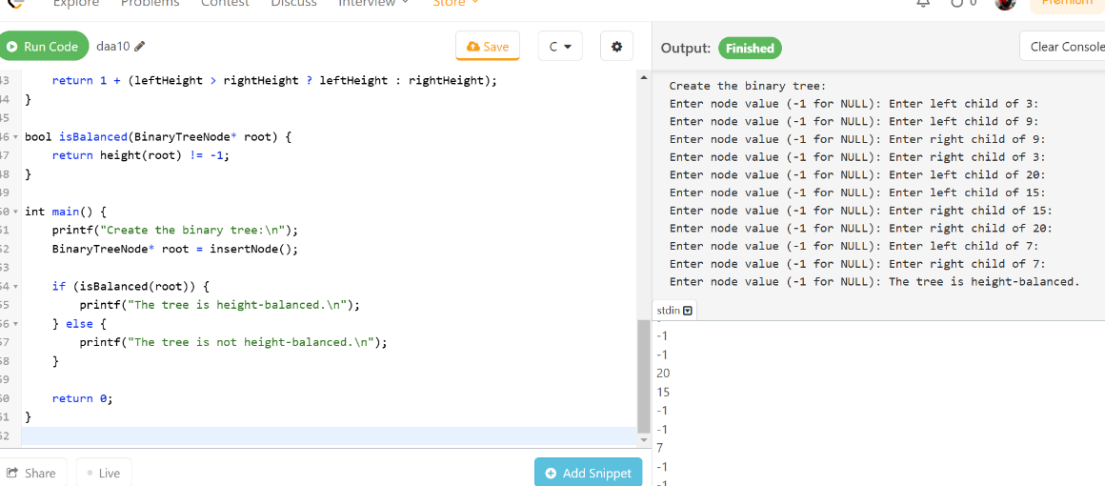

**Case Study:**

Perform Quick sort for the following Array.

**10, 16, 8, 12, 15, 6, 3, 9, 5.**

Analyze Best case, Worst case and Average case Time complexities.

Give an example for array of elements which takes Maximum Time and explain.

Ans. Time Complexities of Quick Sort: Detailed Mathematical Explanation

The time complexity of Quick Sort depends on the number of comparisons made during partitioning and the number of recursive calls. Let us analyze the best case, worst case, and average case step by step.

1. Best Case:

O(nlogn)

When does it happen? The best case occurs when the pivot divides the array into two equal (or nearly equal) halves at each step. For example, choosing the median as the pivot ensures a balanced partition.

Mathematical Analysis:

Number of Levels in Recursion Tree: At each level of recursion, the array is divided into two halves. Starting with an array of size n, the number of levels required to reduce each subarray to size 1 is approximately logn, since halving an array repeatedly results in n divisions.

Number of Comparisons per Level: At each level of the recursion tree, all

n elements of the array are compared during the partitioning step.

Total Number of Comparisons: Since the partitioning happens for n levels and each level processes all n elements, the total number of comparisons is:

Total Comparisons=n+n+n+…(log n times)=n⋅log n

Hence, the time complexity in the best case is:

𝑂(𝑛log𝑛)

2. Worst Case:

𝑂(𝑛^2)

When does it happen? The worst case occurs when the pivot chosen is the smallest or largest element in the array at each step, resulting in highly unbalanced partitions. For example, sorting an already sorted array or reverse-sorted array with the first or last element as the pivot will lead to this situation.

Mathematical Analysis:

Number of Levels in Recursion Tree: At each level, only one element (the pivot) is placed in its correct position, leaving the rest of the array (size n−1) to be sorted. This means there are n levels in the recursion tree.

Number of Comparisons per Level: At the first level, all n elements are compared during partitioning. At the second level, n−1 elements are compared. At the third level, n−2 elements are compared, and so on.

Total Number of Comparisons: The total number of comparisons is the sum of the first n natural numbers:

Total Comparisons=n+(n−1)+(n−2)+⋯+1

Using the formula for the sum of the first n natural numbers:

Total Comparisons= 2n(n+1)

This simplifies to

O(n^2).

3. Average Case:

O(nlogn)

When does it happen? In the average case, the pivot divides the array into two partitions that are roughly proportional in size, but not necessarily equal. On average, each pivot divides the array into partitions of sizes approximately 4n and 3n

Mathematical Analysis:

Number of Levels in Recursion Tree: Similar to the best case, the number of levels in the recursion tree is approximately logn, because the array is divided into smaller and smaller partitions.

Number of Comparisons per Level: At each level, the partitioning step processes all n elements of the array

Expected Total Number of Comparisons: To calculate the expected number of comparisons, we use a recurrence relation. Let T(n) represent the total time taken to sort an array of size n. Partitioning takes O(n) time, and the array is divided into two subarrays of sizes i and n−i−1 (where i is the position of the pivot). Thus, we write:

T(n)=T(i)+T(n−i−1)+O(n)

Averaging over all possible pivots, we assume i is equally likely to be any position 0,1,2,…,n−1. Taking the average, we sum over all values of i:

𝑇(𝑛) = $\sum_{i=0}^{n-1}{[}T\left(i\right)+T(n-i-1)]+O(n)$

Simplifying the recurrence relation and solving using advanced techniques (such as integration or the Master Theorem), the solution converges to:

𝑇(𝑛)=𝑂(𝑛log𝑛)